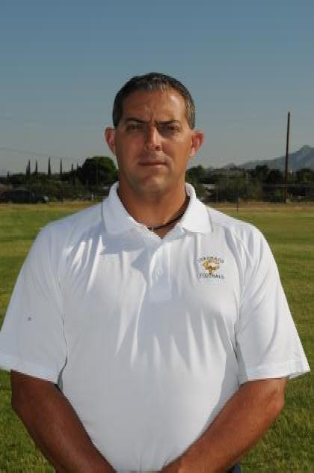
ARA MICHAEL CORBETT
www.coachcorbett.weebly.com
3336 Chickasaw
El Paso, Texas 79936
Cell: (915) 487-9282

PROFESSIONAL OBJECTIVE

To secure full-time employment as a teacher/coach in all levels of physical education and/or health.

EDUCATION

New Mexico Highlands University, Las Vegas, N.M. 87701 (www.nmhu.edu)
Degree: Master of Arts – Human Performance and Sport (Department of Exercise
And Sport Sciences (May 2010)
Major: Human Performance and Sport
GPA: 3.75/4.0
Published: A Study of Concussions by Player Positions in Texas 5A Football
in 2008.

Texas State University (Formally Southwest Texas State Univ.), San Marcos, Texas 78666
(www.txstate.edu)
Degree: Bachelor of Exercise and Sports Science (August 1999)
Major: Physical Education
Minor: Health Education
GPA: 2.75/4.0 while working 40 hours per week
Clubs: Exercise and Sport Science Club, Men Against Violence, The Network
(Health Club), SADD Volunteer, TAHPERD, NASPE

CERTIFICATES/LICENSES

Standard Texas Educator Certificate
All Level Physical Education Grades Pk-12 – Effective 5/1/2010 – 4/30/2016
All Level Health Grades Pk-12 – Expires 4/30/2016

EMPLOYMENT

July 2011- P.E./ Health/ Advanced Health (9-12 Grades)
Present Transmountain Early College High School (TMECHS)
9570 Gateway N.BLVD
El Paso, Tx. 79924
Supervisor: Dianne Jones
(915) 832-4270

July 2008 – Physical Education Instructor (7th Grade)
July 2011 Lincoln Middle School
500 Mulberry
El Paso, Tx.79932
Supervisor: Sandy Whitney, Principal
(915) 231-2180

July 2006 – Physical Education Instructor (PK-5)
July 2008 Oran Roberts Elementary School
341 Thorn
El Paso, Tx. 79932
Supervisor: Richard Chavez
(915) 231-2660

August 2004 – Physical Education Instructor (6-8 Grade)
July 2006 Lincoln Middle School
500 Mulberry
El Paso, Tx.79932
Supervisor: Sandy Whitney, Principal
(915) 231-2180

August 2003 – Physical Education Instructor (At-Risk Students)
July 2004 Raymond Telles Academy
320 South Campbell
El Paso, Texas 79901
Supervisor: Al Nava
(915) 496-4600

ADDITIONAL TRAINING/MEMBERSHIPS/ORGANIZATIONS

Texas High School Coaches Association, American Football Coaches Association, El Paso Coaches Association, Texas Association of Health, Physical Education, Recreation and Dance (TAHPERD), American Association of Health, Physical Education, Recreation and Dance (AAHPERD), National Association for Sports and Physical Education (NASPE), CATCH Certified (December 2003-Present), NASPE Certified Physical Best Health-Fitness Specialist (March 2006 – January 31, 2011), CPR, FIRST AID (expires May 2015), Teacher Mentor Program for young educators, American College of Sports Medicine (ACSM) certified personal trainer. 5 year GOALS include:
1. Becoming a candidate for the Principal Alternative Certification Academy
(PACA). (Spring 2013)
2. Getting certified in Social Studies Composite
3. Getting my certification through ACSM in Clinical Exercise Specialist
and Registered Clinical Exercise Physiologist

Additional Information
- Coordinated School Health Director at TMECHS
- I am extensively trained/experienced in the state mandated FITNESGRAM/ ACTIVITYGRAM. I was even the person in charge of testing and recording at Roberts Elementary.
- I am broadly experienced in teaching with Pedometers and the POLAR heart rate monitors as well as the recording and data analysis
- I am technological literate and am able to incorporate cross curriculum in my classes.
- I am married and have three school age children
- On my free time I love to hang out with family, read, and exercise. I love long runs and biking

REFRENCES
Ms. Dianne Jones, Principal, 9570 Gateway N. Blvd
El Paso, Tx. 79924
(915) 832-4270

Mrs. Sandy Whitney, Principal, 500 Mulberry
El Paso, Tx. 79932
(915) 231-2180

Mr. Sergio Torres, Assistant Principal, 5625 Confetti
El Paso, Tx. 79912
(915) 231-2140

Mr. Pat O’neil, Assistant Superintendent SISD, 12440 Rojas
El Paso, Tx. 79928
(915) 937-0053

Mr. Mike Williams, Athletic Director (YISD), 9600 Sims Dr.
El Paso, Tx. 79925
(915) 434-0633

Mr. Ronald Durkes, Athletic Director (SISD), 10928 Lakewood
El Paso, Tx. 79935
(915) 598-1384

Mr. Javier Carrasco, Coordinated School Health Program Assistant
6531 Boeing Drive, El Paso, Tx. 79925
(915) 772-4577

Mr. Joe Joachim, Physical Ed. Department Head @ Lincoln Middle School
500 Mulberry, El Paso, Tx. 79932
(915) 346-2511

Ms. Angelica Negrete, Coordinator, Health, Wellness and Physical Education
Curriculum and Instruction
(915) 230-2361

COACHING EXPERIENCE
July 2004 – CORONADO HIGH SCHOOL
Present 100 Champions Pl., El Paso, Tx. 79912
(915) 834-2460
Supervisor: Marielo Morales, Don Brooks (Head Football Coach),
Bob Anderson (2012 – Present)
Forrest Rich (Head Wrestling Coach), Raul Melendez (Head
Softball Coach)
Head Freshman Football Coach Specialize in offensive
Coordinator, QB’s, RB’s, and DB’s
- Assistant Wrestling Coach
- Assistant Softball Coach
- Varsity Punters, Kickers, Secondary

August 2003 – BOWIE HIGH SCHOOL
May 2004 801 San Marcial, El Paso, Tx., 79901
(915) 496-8200
- Varsity Defensive Ends (Split 6)
- J.V. Defensive Coordinator
August 2002 – TORNILLO HIGH SCHOOL
May 2003 PO Box 170
430-A Oil Mill Rd.
Tornillo, Tx. 79853
- Varsity Defensive Line Coach
- J.V. Defensive Coordinator
- Varsity Boys Basketball Assistant (District Champs)
- Head J.V. Boys Basketball Coach (16-3, 9-1 District Champs)
- Assistant Varsity Boys Baseball Coach

August 1999 - ST. PATRICK CATHEDRAL MIDDLE SCHOOL
May2002 1111 N. Stanton, El Paso, Tx. 79902
(915) 532- 4142
- Athletic Director
- Head Flag Football Coach
- Head 5th/6th and 7th/8th volleyball coach
- Head Boys and Girls 7th/8th basketball
May 2000 – CATHEDRAL HIGH SCHOOL (TAPPS 5A)
May 2002 1309 N. Stanton, El Paso, Tx, 79902
(915) 532-3238
- Varsity DB’s, Receivers, Special Teams
- Head J.V. Football
- Athletic Trainer

